IP ADDRESS
- A Unique 32-bit address.
- Used by computers to communicate over a computer network.
- Known as: Logical Address because it is a software address assigned to each machine on network.
- Why Need? : Necessary for Universal communication services that are independent of underlying networks.
- Used In : Universal Addressing System
- Universal Addressing System is one where each host can be identified uniquely regardless of the underlying physical network.
- Used at Network layer of OSI Model.
- Designed to allow a host on one network to communicate with host on a different network.
- We can change IP Address but can’t change MAC Address because it is hard coded on NIC.
- Each IP address has two fundamental parts:
    - Network Address.
    - Host Address.
Network Number or Address:
- Uniquely identify each network.
- This number is common to all computers on the same network and define the network group the computer belong to.
Host Number:
- Consist number that are unique to each computer on the network.
- Useful to uniquely identify each computer on the network.
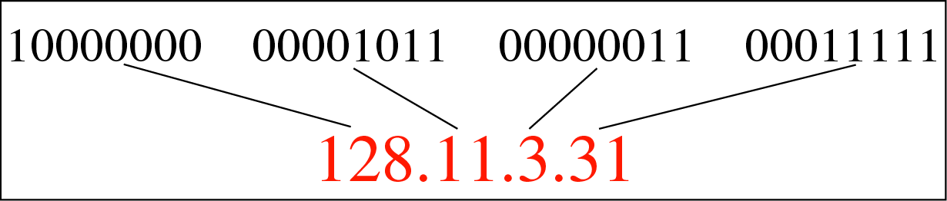
128.11 : Network Addressand3.31 : Host Address

- IP addresses are written in
    - Dotted Decimal format and
    - Binary format.

- We cannot mix binary notation and decimal notation to write down IP Address.
Dotted Decimal Format: Dots separate the sections
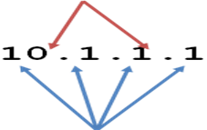
Each section contains a number between 0 and 255.

- Four sections are separated by dots.
- Each section contains a number between 0 and 255.
- Each section is known as OCTET.

Binary Format:
- To write ip address into binary format we use “1” and “0”.
- Each octelcontail 8 bits. Because 32 bit / 4 boctet = 8 bit / octel.

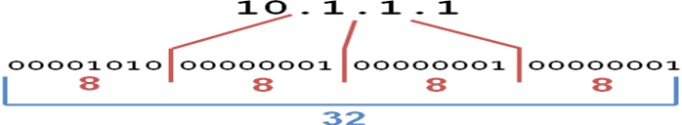
Each 8 digit group represents a number between 0 and 255

Why is each section a number between 0 and 255?
- Computers operate in binary, humans operate in decimal.
- Computers treat IP addresses as a single large 32 digit binary number, but this is hard for people to do.
- So, we split them up into four smaller sections so we can remember and work with them better
It is structure or hierarchical Address.
- IP address is used in routing.
- If every machine has unique address then all router on the internet would need to store the address of each and every machine on the internet.
- This make router inefficient.
- Solution : 32 bit is divided into two parts.
  - Network Address
  - Host Address

ADDRESS SPACE
- Definition: A protocol such as IPv4 that defines range of addresses which is also called as address space.
- An address space is the total number of addresses used by the protocol.
- The address space in a protocol That uses N-bits to define an address is: 2^{N}.
- IPv4 uses 32-bit addresses, which means that the address space is 2³²or 4,294,967,296 (more than 4 billion).
- This means that, theoretically, more than 4 billion devices as mentioned above could be connected to the Internet.

DIFFERENCE :MAC ADDRESS Vs IP ADDRESS
MAC address | IP address
Functions at data link layer | Functions at network layer
It is a physical address | It is a logical address
It is fixed. | It changes with the relocation of device from one network to another
It is a 48 bit address | It is a 32 bit address

CLASSFUL ADDRESSING
- IPv4 addressing used the concept of classes.This architecture is called classfull addressing.
- In classfull addressing, the address space is divided into five classes: A, B, C, D, and E.
- Each class occupies some part of the address space.
- If the address is given in binary notation, the first few bits can immediately tell us the class of the address.
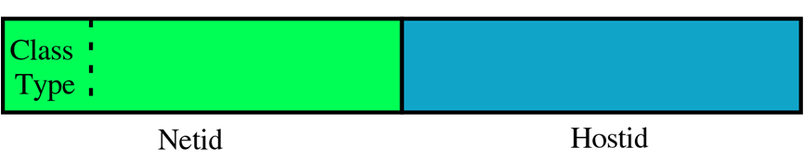
Why Devided into Classes?:IP addresses are divided into classes so that they can be assigned to a particular business, government or other entity based on size and need. There are five IP classes plus certain special addresses
- If the address is given in decimal-dotted notation, the first byte defines the class.
- when IP was developed, the IP address space was divided into distinct IP address classes to determine where the network portion stops and the host portion begins.
- The value of the first octet and its highest order (leftmost) bits determine the class.
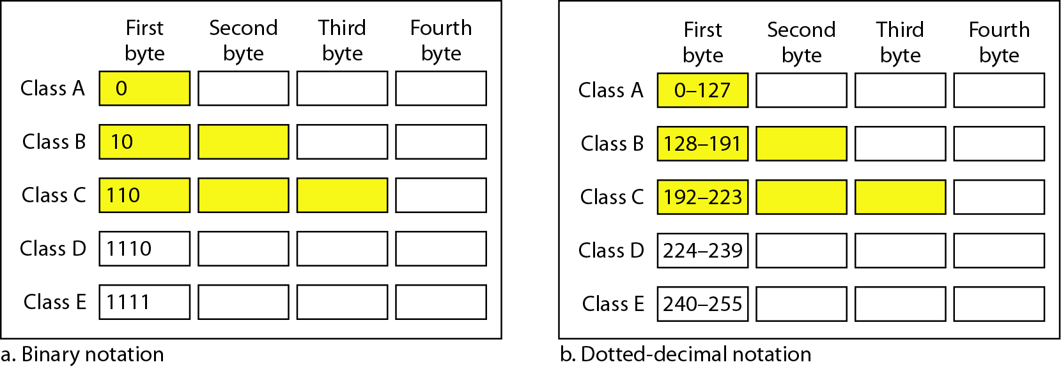
- There are five IP address classes, three of which (A, B, and C) are available for commercial use. Class D is reserved for IP multicasting. Multicasting allows multiple computers in the same multicast group to receive the same data transmission, sort of like a directed broadcast.
- Class E is strictly reserved for research use by the Internet Engineering Task Force

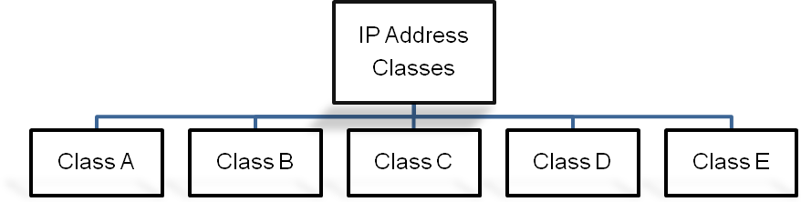

CLASS A
- In a Class A IP address, the network portion is represented by the first octet; it has in its leftmost bit.
- All Class A IP addresses fall into the 0-127 range for the first octet.
- This also results in 127 possible networks and a maximum of 16,777,214 hosts on each network. (Please note that the network 127.0.0.0 is reserved for loopback addresses.) Figure summarizes the characteristics of the Class A address class.

CLASS B
- In a Class B IP address, the first and second octets represent the network portion; it has 10 in its two leftmost bits.
- A Class B IP address falls into the 128 to 191 range for the first octet.
- This results in 16,384 possible networks and a maximum of 65,534 hosts on each network.
CLASS C
- In a Class C IP address, the network portion is represented by the first, second, and third octets; it has 110 in its three leftmost bits.
- A Class C IP address falls into the 192 to 223 range for the first octet. This results in 2,097,152 possible networks and a maximum of 255 hosts on each network.
SUBNET MASK
- Subnet mask is used to differentiate Network ID and Host ID.
- Each class has Default Subnet Mask in classful Addressing.
- To differentiate, perform AND operation with IP Address and Subnet Mask.
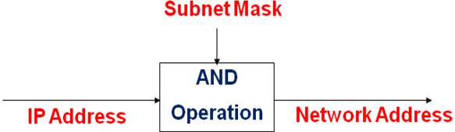
Definition: 32 bit value that allow recipient of IP packets to distinguish the network id and host id portion of the IP Address.”
DEFAULT SUBNET MASK
- Class A, B and C contains 1s in network ID fields for default subnet mask.
- The bits of the subnet mask are defined as follows:
  - All bits that correspond to the network ID are set to 1.
  - All bits that correspond to the host ID are set to 0.
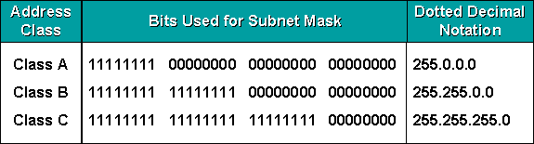
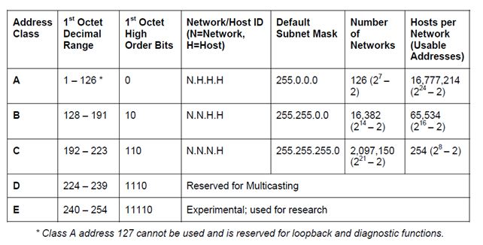
Note that we must not apply the default mask of one class to an address belonging to another class.

HOW TO FIND NETWORK ID IN CLASSFUL ADDRESS?
SHORTCUT METHOD:
- If the byte in the mask is 255, copy the byte in the address.
- If the byte in the mask is 0, replace the byte in address with 0.
For example:
Given the address 23.56.7.91, find the beginning address (network address).
IP | 23 | 56 | 7 | 91
SUBNET MASK | 255 | 0 | 0 | 0

NETWORK ID | 23 | 0 | 0 | 0

OR From the first octet value we get idea about the class. Here 23, it is reside between “0-128” so its class A address. In Class A , only fist octet define network id and other octet define host address so we cant need to do above trick or apply Anding operation .
DEFAULT GATEWAY
- It is a term used by TCP/IP for a Router.
- IP address of a router on the same subnet is called the default Gateway.
- Subnet Mask is to identify whether the source and destination machines are on the same subnet.
- In the destination machine is on the another subnet then the message is sent through routers.
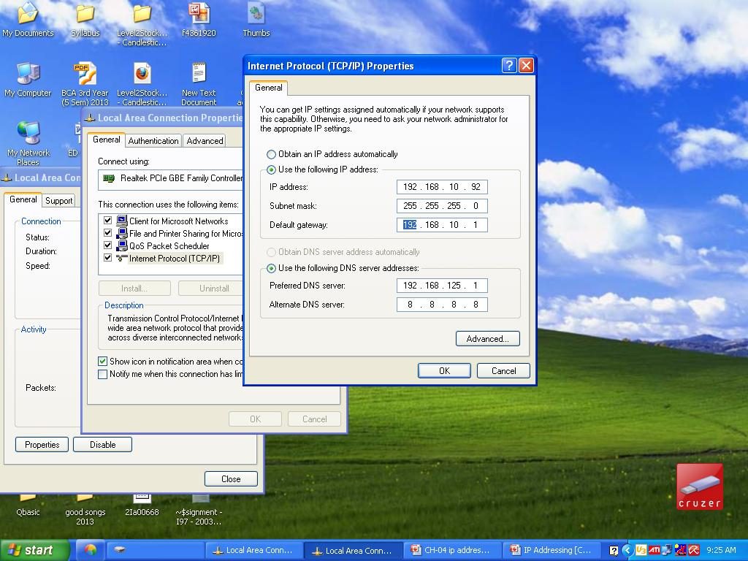

PING UTILITY:
- Full Form : Packet InterNet Groper Utility
- Diagnostic Tool used for troubleshooting purpose.
- Use from command prompt by writing : ping <computer ip address/host name>
To check connection between two machines.
- Use:
    - To test TCP/IP configuration and to identify connection failures.
    - To determine whether a destination is alive and reachable.
IPCONFIG
- Full Form : InternetPacket Configuration
- Displays all current TCP/IP network configuration values
- Refreshes Dynamic Host Configuration Protocol (DHCP) and Domain Name System (DNS) settings.
- Used with /all(ipconfig /all)parameters, ipconfig displays the IP address, subnet mask, and default gateway for all adapters with host name.
PRIVATE ADDRESSES:
- Used by anyone on Private Network.
- Are not routable .
- Can not access from internet.
- Save IP Address Space.
- Internet Assigned Numbers Authority (IANA) has reserved certain IP addresses as private addresses for use with internal web sites or intranets.
- These are also referred to as RFC 1918 addresses.
- If every host on network as real routable IPaddress , we would have run out of IP Address space.
- Used forcomputer not directly connected with internet.
- Used by company for internal network
CLASS | RESERVED ADDRESS SPACE | AVAILABLE ADDRESS
A | 10.0.0.0 - 10.255.255.255 | 16,777,216
B | 172.16.0.0 - 172.31.255.255 | 1,048,576
C | 192.168.0.0 - 192.168.255.255 | 65,536

PUBLIC ADDRESSES:
- A public IP address is any valid address, or number, that can be accessed over the Internet.
- Internet standards groups, such as the Internet Assigned Numbers Authority (IANA), are the organizations responsible for registering IP ranges and assigning them to organizations, such as Internet Service Providers (ISPs).
LOOPBACK ADDRESSE:
- 127.0.0.1 is a Loopback Address
- Use:
    - A host can use this to send message back to itself.
    - Primarily for Troubleshooting and network testing.
- It check if the TCP/IP protocol stack on machine is working properly or not.
- 127.0.0.0 to 127.255.255.255 reserve for loopback address

TYPES OF IP ADDRESS CONFIGURATION
There are two types
- Static
- Dynamic
Static
- Manually input by network administrator.
- Manageable for small networks.
- Requires careful checks to avoid duplication.
Dynamic
- Assigned by server (DHCP ) when host boots.
- Derived automatically from a range of addresses.
- Duration of ‘lease’ negotiated, then address released back to server.
IP SUBNETTING
Why we need?
- IP address classes are not always the most efficient way to design an IP addressing scheme. There aren't many companies that need a Class A address with 16 million hosts, and there may be smaller companies that need more addresses than a Class C network can provide. As you can see, this method could lead to a tremendous number of wasted IP addresses
- The Internet Engineering Task Force (IETF) saw this and submitted RFC 950 to facilitate the addition of a third level to the existing two-level hierarchy created with IP address classes. This third level is known as subnetting.
- Definition: Subnetting allows you to divide a network into smaller sub-networks.
- Use parts of the host IDs for subnetting purpose.
- Subnets are created by taking leftmost bits from the host portion of an IP address and applying them to the network portion (see Figure).
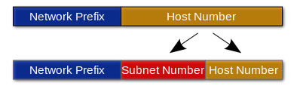
- Each subnet has its own sub-network address.
- Subnet can be created within Class A, B, or C based networks.
- In class C address, 8 bit used for Host address,so if we want to subnet, we have to use some bit from host address.
SUBNET:
- A subnet is a logical grouping of connected network devices.
- It is a logical visible subdivision of an ip network.
- All computer that belong to a subnet are addressed with a common identical most significant bit group in ip address.
- Also known as Subnetwork.
METHOD TO FIND NUMBER OF SUBNET AND HOST ADDRESS PER SUBNET
Number of Subnet: 2^{X}Where x is the number of masked bits , or the ‘1’s.
To find the number of subnet, we have to count number of ‘1’ in subnet mask.
2^{N}-2.
For example: In class A subnet mask is 255.192.0.0 (11111111.11000000.00000000.00000000). Total on bit means 1 in subnet mask is 8. So we get 2² = 4sub network address.

Number of Host Address Per Subnet: 2^{y}-2, Where y is the number of unmasked bits or the ‘0’s.
To find the number of host address per subnet, we have to count number of ‘0’ in subnet mask.
For exampleIn class A subnet mask is 255.192.0.0 (11111111.11000000.00000000.00000000). Total off bit means ‘0’ in subnet mask is 22. So we get 2²²-2network address.

Valid Subnet: 256 – subnet mask = block size or increment number.
For example: In class A subnet mask is 255.192.0.0 (11111111.11000000.00000000.00000000).
Here we get : 256 – 192 = 64. So the block size of 192 mask is always 64.
Start counting at zero in blocks of 64 until we reach the subnet mask and there are our subnets.
Here we get following subnet :0, 64, 128, 192

Broadcast Address of Each Subnet:Broadcast address is always the right number before the next subnet.
For example: The ‘0’ subnet has a broadcast address of 63 because the next subnet is 64. The 64 subnet has a broadcast address of 127 because the next subnet address is 128. Note that the broadcast address of last subnet is always 255. So , in above example the broadcast address of subnet ‘192’ is 255.

SUBNETTING PRACTISE EXAMPLES
Find the number of subnet, number of host per subnet, valid subnet and broadcast address for following Class “C” network address.
Network Address | 192.168.10.0
Subnet Mask | 255.255.255.192

Here we get network address of Class ‘C’ address because from the first octet ‘192’ we say that its class ‘c’ address.
Now , we convert subnet mask and default mask of class “C” address in binary format
Default Subnet mask | 255.255.255.0 | 1111 1111. 1111 1111. 1111 1111. 0000 0000
Subnet Mask | 255.255.255.192 | 1111 1111. 1111 1111. 1111 1111. 1100 0000

Here we on 2 bit from host address part of class “C” address.
To give all answer of above question we concentrate on Host octet. In class “C” address last octet means only last 8 bit are used for host address.
Number of Subnet: 2^{x} = 2²since 192 ( 1100 0000)where 2 is ON bit from default mask.
Number of Host Per Subnet: From above table we see that 6 bits of last octet are off. So from the method 2^{y} – 2, we get 2⁶ – 2 = 62 host.
Valid subnet: 256 -192 = 64
To find valid subnet , we start from the 0 so valid subnets are: 0,64,128,192.
Broadcast Address of Each Subnet: The number right before the next subnet is broadcast address of subnet.
Check the table for Fist host address, Last host address and broadcast address of each subnet.

Subnet | 0 | 64 | 128 | 192
First Host Address | 1 | 65 | 129 | 193
Last Host Address | 62 | 126 | 190 | 254
Broadcast Address | 63 | 127 | 191 | 255

From the use of above table find the subnet of following IP address
Node Address | 192.168.10.88
Subnet Mask | 255.255.255.192

- Now check the above table , we say that from IP Address : 192.168.10.88 its class c address so that first 3 octet display Netid and last octet display Node or Host ID. Here 88 is Host id.
- Now from the table , we say that “88” is come between subnet number 64 and 128.
- So the network id for IP Address : 192.168.10.88 is 192.168.10.64
OR
SHORT CUT METHOD
- If the byte in the mask is 255, copy the byte in the address.
- If the byte in the mask is 0, replace the byte in the address with 0.
- If the byte in the mask is neither 255 nor 0, we write the mask and the address in binary and apply the AND operation
Node Address | 192.168.10.88
Subnet Mask | 255.255.255.192

Subnet Address | 192.168.10.64
- Here we copy all octet above the 255, so we copy 192.168.10.
- But for last octet in subnet mask is not 255, so we take both number from Node address and Subnet Mask and change it in binary form and perform AND operation.
88 | 0101 1000
192 | 1100 0000
AND | 0100 0000
- Here the final result is : 0100 0000 = 64. So we get last octet.
- Now write Full subnet address : 192.168.10.64
Exercise:A company is granted the site address 201.70.64.0 (class C). The company needs six subnets. Design the subnets, Find number of host per subnet andFind the broadcast address.
- The company needs six subnets.
- This number 6 is not a power of 2.
- The next number that is a power of 2 is 8 (2³).
- We need 3 more 1s in the subnet mask. The total number of 1s in the subnet mask is 27 (24 + 3).
- The total number of 0s is 5 (32 - 27). The mask is 255.255.255.224
1111 1111. 1111 1111 .1111 1111 .11100000
- Here we on 3 bit from host address part of class “C” address.
- To give all answer of above question we concentrate on Host octet. In class “C” address last octet means only last 8 bit are used for host address.
- Number of Subnet: 2^{x} = 2³since224( 1110 0000)where 3 is ON bit from default mask.
- Number of Host Per Subnet: From above table we see that 6 bits of last octet are off. So from the method 2^{y} – 2, we get 2⁵ – 2 = 30 host.
- Valid subnet: 256 - 224 = 32
- To find valid subnet , we start from the 0 so valid subnets are: 0,32,64,96,128,160,192,224.
- Broadcast Address of Each Subnet: The number right before the next subnet is broadcast address of subnet.
- Check the table for Fist host address, Last host address and broadcast address of each subnet.
Subnet | 0 | 32 | 64 | 96 | 128 | 160 | 192 | 224
First Host Address | 1 | 33 | 65 | 97 | 129 | 161 | 193 | 225
Last Host Address | 30 | 62 | 94 | 126 | 158 | 190 | 222 | 254
Broadcast Address | 31 | 63 | 95 | 127 | 159 | 191 | 223 | 255

Exercise:A company is granted the site address 181.56.0.0 (class B). The company needs 1000 subnets. Design the subnets.
- The number of 1s in the default mask is 16 (class B).
- The company needs 1000 subnets.
- This number is not a power of 2.
- The next number that is a power of 2 is 1024 (2¹⁰). We need 10 more 1s in the subnet mask.
- The total number of 1s in the subnet mask is 26 (16 default mask + 10 from host address).
- The total number of 0s is 6 (32 - 26).
- The mask is : 255.255.255.192
11111111 .11111111 .1111 1111. 11000000
- The number of subnets is 1024. Because we have 10 bit on.
- The number of addresses in each subnet is 2⁵(5 is the number of 0s) or 32.
Which criteria should be kept in consideration while selecting topology?
Following criteria should be kept in consideration while selecting topology.
- Capabilities of the equipment.
- Type of equipment the network needs.
- Growth of the network.
- Way the network is managed.
- Security.
- Scalability.
- Reliability.
- Performance.

HOW TO SHARE PRINTER?
To share printer on windows 7 OS follow following steps.
1. Open the Windows Control Panel.
2. Select "Network and Sharing Center."
3. Click "Change advanced sharing settings."
4. Click the downward facing arrow to expand the current network profile.
5. Under File and printer sharing, select "Turn on file and printer sharing."
6. Click "Save changes" and enter your password if necessary. This will turn on file and printer sharing.
7. Click the Start menu, then select "Devices and Printers."
8. Right-click the printer you want to share, then click Printer properties.
9. Click the Sharing tab, and check the box next to "Share this printer."
Once you have completed the above steps, other computers connected to your local network will be able to access the shared printer. In order to use the printer, each user will need to add the printer by following the steps below.
1. Click the Start menu, then select "Devices and Printers."
2. Select "Add a printer."
3. Click "Add a network, wireless, or Bluetooth printer."
4. Select the shared printer and click next.
5. Follow the instructions on the screen to set up your printer.
EXPLAIN HOW TO INSTALL AND CONFIGURE NIC
Install NIC
- Power down PC and remove the AC power cord.
- Open the computer case.
- Find an available Peripheral Component Interconnect (PCI) slot on the motherboard and remove slot insert if one exists.
- Carefully remove the network card from its static-proof plastic envelope, and slide it into the slot.
  - Seat the card in the slot firmly with gentle pressure along the length of the card, especially right about the slot itself.
  - Screw the card to the computer frame, but do not over tighten.
- Close the computer case.
- Plug your computer in and power it up.
- Click Start, then click Control Panel.
- Click "System" icon at bottom of window.
- Click the Hardware tab.
- Click the Device Manager button.
- Double-click Network Adapters.
  - Beneath it should appear the name of your Ethernet card.
- Next, double click the name of your Ethernet adapter.
  - If the text in the "Device Status" box says "This device is working properly.", then you successfully installed the card and are finished.
  - If the text in the "Device status" box doesn't say "This device is working properly.", then write down on a piece of paper what it says and continue with next step.
- Click the Troubleshoot. Button and follow instructions.
Configure NIC
- Click on Start and Control Panel.
- Click on the Network Connections icon under the heading .
- Double click on the Local Area Connection icon that corresponds to your network card
- This shows the Local Area Connection status. Click on the Properties button
- Double click on Internet Protocol (TCP/IP)
- For static IP address, place a dot beside "Specify an IP address" and enter the IP address, subnet mask, and Default Gateway. For DHCP (Dynamic Host Configuration Protocol), place a dot beside of "Obtain IP address automatically"
- If not already so, place a dot beside "Use the following DNS server addresses" and enter the primary and secondary DNS addresses
Click OK and then click OK again
SERVER
- A Server is a computer that provides services such as shared resources like data, software, peripherals to client computers.
- Types Of Server
File Server | Application Server | E-mail Server | DNS
DHCP | Web server | Database Server | Print Server
FILE SERVER
- A file server is a computer attached to a network.
- That has the primary purpose of providing a location for shared disk access, i.e. shared storage of computer files such as documents, sound files, photographs, movies, images, databases, etc. that can be accessed by the workstations that are attached to the same computer network.
- The term server highlights the role of the machine in the client–server scheme, Where the clients are the workstations using the storage.
- A file server is not intended to perform computational tasks, and does not run programs on behalf of its clients.
- It is designed primarily to enable the storage and retrieval of data while the computation is carried out by the workstations.
- File servers are commonly found in schools and offices, where users use a LAN to connect their client computers.
Types Of File Server
- A file server may be
- Dedicated
- Non-dedicated.
Dedicated File Server
- A dedicated server is designed specifically for use as a file server, with workstations attached for reading and writing files and databases.
- A dedicated file server means that there may be a specific computer server that fulfills this function, typically for a larger network, and has specialized hardware and software to handle the greater workload.
- This may include more hard drive memory storage, better cooling systems, better security such as limited physical access, and specialized software contained within special server operating systems.
Non-Dedicated File Server
- A non-dedicated file server just means that the computer functioning as a file server isn't used exclusively as such, and may also be used for other purposes, such as a workstation. This is more typical of small-scale systems, such as at home or in a small business.
- File servers may also be categorized by the method of access:
- Internet file servers are frequently accessed by File Transfer Protocol (FTP) or by HTTP
- Servers on a LAN are usually accessed by SMB/CIFS protocol (Windows and Unix-like) or NFS protocol (Unix-like systems).
APPLICATION SERVER
- An application server supplies shared capabilities to software applications on client server networks.
- Application server provide services to the network clients or support enterprice based applications.
- It is a server computer in a computer network dedicated to running certain software application.
- Some application servers keeps data and the application on the same computer, but it varies by application.
- Application server are specific to the applications they support, such as database server or business related applications.
- For example, websites use at least one application server may be used in a supporting role, such as database server storing content used by the web server and hosted websites.
E-MAIL SERVER
- Often referred as mail server
- Receives and delivers e-mails over the network .
- Maintains a storage area for e-mails.
- Employs a set of user defined rules that determine the strategy for mail server to respond according to the destination of a specific message .
DHCP
- Full Form : Dynamic Host Configuration Protocol
- Provides dynamic configuration of IP addresses on time lease basis.
- Backward compatible with BOOTP .
- DHCP Server employs manual, automatic and dynamic IP address allocation methods
- Reduces administration of a TCP/IP network .
Responsibility of DHCP:
- Lease Management
- Responding To Client Requests
- Providing Administration Services
DNS
- Full Form: Domain Name System.
- Technique used to provide standard naming conventions for finding IP address configured hosts
- Because domain names are alphabetic, they're easier to remember. The Internet however, is really based on IP addresses.
- When you use an alphanumeric address such as WWW.EXAMPLE.COM, your computer needs to understand what numerical IP addresses it needs to contact, and this is accomplished through DNS servers. The answer is delivered back to the requesting computer via the DNS as IP Address to computer.
- Based on hierarchical and logical tree structure called Domain Namespace Internet domains are classified into various categories like “root” or the top most level of the Internet domain namespace.
WEB SERVER
- Web servers are computers that deliver (serves up) Web pages.
- Every Web server has an IP address and possibly a domain name. For example, if you enter the URL http://www.pcwebopedia.com/index.html in your browser, this sends a request to the Web server whose domain name is pcwebopedia.com.
- The server then fetches the page namedcindex.html and sends it to your browser.
- Any computer can be turned into a Web server by installing server software and connecting the machine to the Internet. There are many Web server software applications, including public domain softw.are from NCSA and Apache, and commercial packages from Microsoft, Netscape and others.
PRINT SERVER
- A print server, or printer server, is a device that connects printers to client computers over a network.
- It accepts print jobs from the computers and sends the jobs to the appropriate printers, queuing the jobs locally to accommodate the fact that work may arrive more quickly than the printer can actually handle.
- Functions include the ability to inspect the queue of jobs to be processed, the ability to reorder or delete waiting print jobs, or the ability to do various kinds of accounting (such as counting pages, which may involve reading data generated by the printer(s)).
- Print servers may support a variety of industry-standard or proprietary printing protocols including Internet Printing Protocol, Line Printer Daemon protocol, NetWare ,NetBIOS/NetBEUI
- A print server may be a networked computer with one or more shared printers.
- Alternatively a print server may be a dedicated device on the network, with connections to the LAN and one or more printers.
- Dedicated server appliances tend to be fairly simple in both configuration and features. A printer may have a built-in print server.
- All printers with the right type of connector are compatible with all print servers; manufacturers of servers make available lists of compatible printers.

